Experiment No 4

Title:
Data Input and Storage in the GrocerySpot App

Objective:
To understand the working of forms and storage in the GrocerySpot mobile application.

Theory:

Adding functionality to input data into your app, such as a form or questionnaire:
In the GrocerySpot app, we have introduced a feature to enhance user engagement and satisfaction through the incorporation of a feedback mechanism and a product image upload option. This admin interface allows for seamless interaction with users, facilitating the collection of valuable insights and the resolution of any product-related issues.

Feedback Form: The admin interface now includes a feedback form powered by Google Forms, enabling users to provide valuable feedback regarding their shopping experience, product quality, or any other relevant aspects. By leveraging Google Forms, we ensure a user-friendly and efficient feedback submission process, enhancing user engagement and satisfaction.

Product Image Upload: Additionally, users can now upload images of faulty products directly through the app interface. This feature enables users to report any issues or defects with purchased products visually, providing clarity and specificity to aid in swift resolution. By allowing users to upload images, we streamline the troubleshooting process for product-related concerns, trust and transparency between the users and the GrocerySpot platform.

By integrating these features into the admin interface, GrocerySpot empowers users to actively participate in improving the platform's offerings and overall user experience. The feedback mechanism facilitates continuous refinement and enhancement of product offerings, while the product image upload option ensures prompt resolution of any issues or discrepancies encountered by users. Ultimately, these features contribute to building a strong rapport with users and reinforcing GrocerySpot's commitment to delivering exceptional service and satisfaction.

Exploring different data input controls like checkboxes, dropdowns, and sliders:
Dropdowns, checkboxes, and sliders are indispensable elements in enhancing user interaction within the GrocerySpot app. Let's elaborate on their roles and how they contribute to improving the user experience:

Dropdowns: Dropdown menus offer users a convenient way to select categories or attributes related to grocery products. For instance, users can easily choose their preferred location from a dropdown menu, enabling them to filter products based on their proximity or availability in specific areas. This streamlined approach simplifies the product browsing experience and helps users find relevant items quickly.

Checkboxes: Checkboxes allow users to select multiple options or preferences simultaneously. In the context of the GrocerySpot app, checkboxes can be used for indicating dietary preferences, such as vegetarian or non-vegetarian options. By enabling users to specify their dietary choices with checkboxes, the app caters to a diverse range of dietary needs and preferences, enhancing user satisfaction and personalization.

Sliders: Sliders provide users with an intuitive method for adjusting numerical values, such as price ranges or product quantities. For instance, users can slide a control to set their desired price range, enabling them to narrow down search results based on their budget preferences. Similarly, sliders can be utilized for specifying the quantity of a particular product, allowing users to customize their shopping experience according to their requirements.
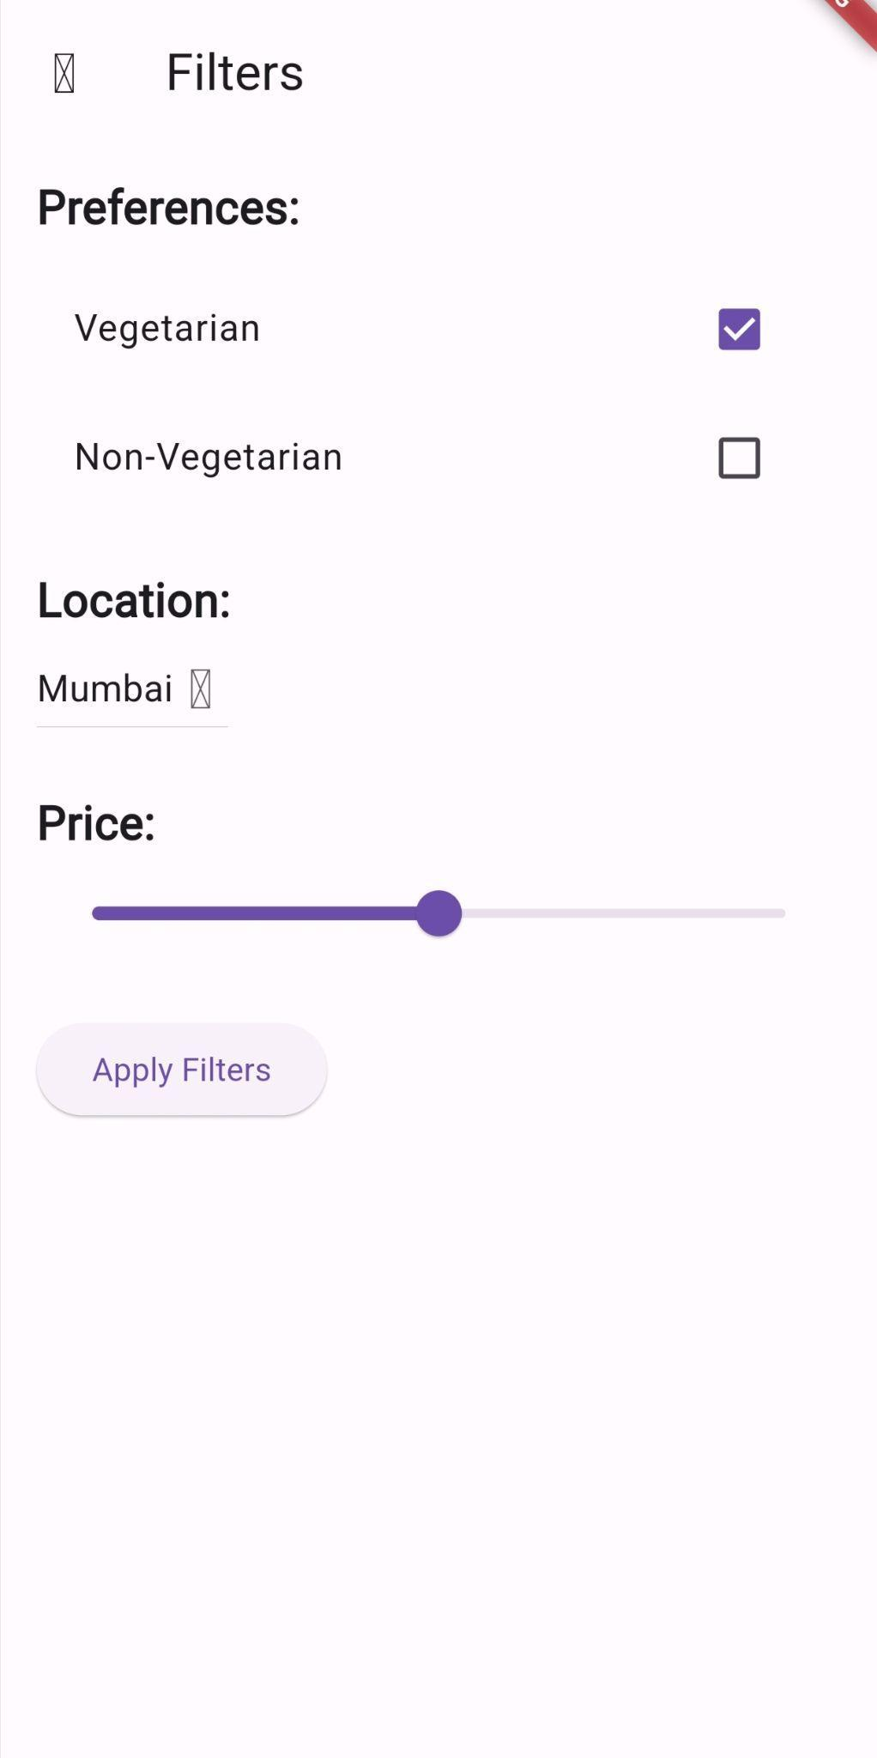

Conclusion:
The implementation of data input forms and storage mechanisms in the GrocerySpot app has significantly enhanced the user experience and functionality of the application. By providing intuitive forms for inputting product details and employing various input controls such as dropdowns, checkboxes, and sliders, the app offers users a seamless and interactive shopping experience. Furthermore, the use of Firebase Realtime Database for data storage ensures scalability, efficiency, and real-time synchronization of product information across all devices. Overall, the integration of data input and storage features has contributed to a more robust and user-friendly app experience, empowering users to make informed decisions while shopping for groceries.

